
SYMBIOSIS INTERNATIONAL (DEEMED UNIVERSITY)
(Established under section 3 of the UGC Act, 1956)
Re-accredited by NAAC with ‘A’ grade (3.58/4) | Awarded Category – I by UGC
Seat No.

Institute: (0701) SYMBIOSIS INSTITUTE OF TECHNOLOGY, PUNE

Programme: (070122, 070124) BACHELOR OF TECHNOLOGY (CS & IT)

Batch: (2015-19, 2016-20)
Semester: IV
Course: Data Structures
Course Code: 0701220405-CS, 0701240405-IT

Date: 26/12/2020 Maximum Marks: 45

Day: Saturday Time: 3:00 pm – 4:30 pm

Instructions:
- All questions are compulsory.
- Make suitable assumptions wherever required.

Q.1 | a) | State & explain different types of linked lists. | 2 | CO1
 | b) | Explain stack implementation using linked list. | 6 | CO1
Q.2 | a) | Explain linked & sequential representation of binary tree with diagrams. | 2 | CO2
 | b) | Write an algorithm to implement following Threaded Binary Tree operations:  - Create  - Postorder traversal | 6 | CO2
Q.3 | a) | Explain any one representation of graph data structures. | 2 | CO3
 | b) | Find the shortest paths to all vertices in the following graph from vertex 1 as the source vertex. Show all steps.  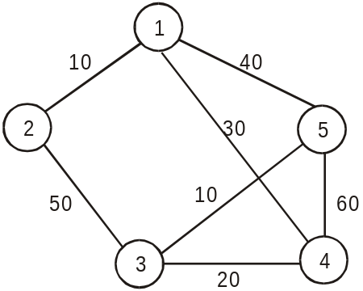 | 6 | CO3
Q.4 | a) | Explain concept of symbol table. | 2 | CO4
 | b) | Produce the AVL tree for the following values:  15, 20, 24, 10, 13, 7, 30, 36, 25 | 6 | CO4
Q.5 | a) | What are the characteristics of a good hash function? | 2 | CO5
 | b) | Explain concept of chaining with & without replacement collision resolution strategy with suitable examples. | 6 | CO5
Q.6 |  | Write short note on direct access file organizations. | 5 | CO6

**********************************

